Creamy Pappardelle Pasta



12 oz. pappardelle pasta

1 t salt

1½ T olive oil

½ lb. ground sausage

½ lb. hamburger

½ large sweet onion, chopped fine

3 cloves garlic, minced

4 oz. tomato paste

1½ c beef broth

1½ c heavy whipping cream

1 T fresh lemon juice

1½ c grated parmesan, divided

3 T chopped Italian parsley

Salt and pepper to taste

Cook pasta and salt in boiling water in large pot according to package directions. Meanwhile heat olive oil in large skillet over medium heat. Add sausage and hamburger and cook, breaking up and stirring occasionally, until browned. Add onions and cook 2-3 minutes. Stir in garlic. Add tomato paste, beef broth, and lemon juice. Cook and stir until boiling. Turn heat to low and add heavy whipping cream. Using tongs remove pasta from pot and add to skillet, reserving pasta water for future use. Add 1 cup parmesan and stir until melted and smooth. Thin with additional pasta water as needed to achieve desired consistency. Salt and pepper to taste and serve warm with additional grated parmesan and parsley as a garnish.

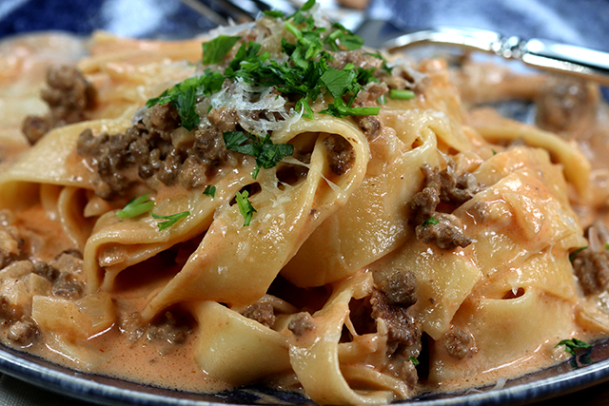

www.thecupcaketheory.com